PROJECT: ludovico99_fastjson

REPO: <https://github.com/ludovico99/fastjson>

HASH: 7228bc37841380ff8b9972ac32a89e6d773239d8

LINK SONARCLUD: [fastjson - 2022-mmqs-MW-org (sonarcloud.io)](https://sonarcloud.io/summary/overall?id=com.alibaba%3AfastjsonMW)

SCREEN MAVEN

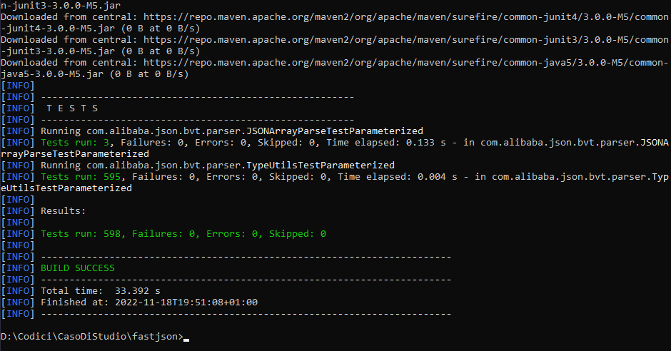

SCREEN SONARCLUD

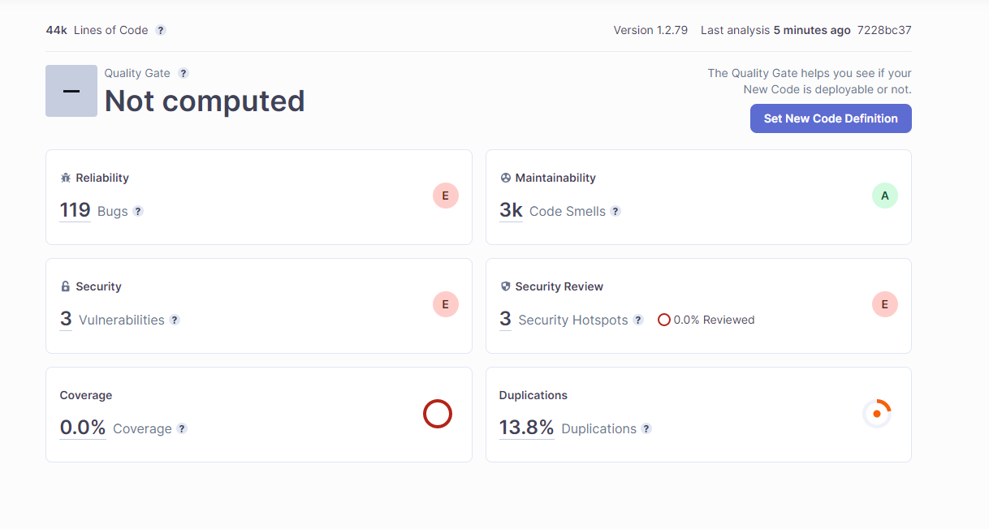

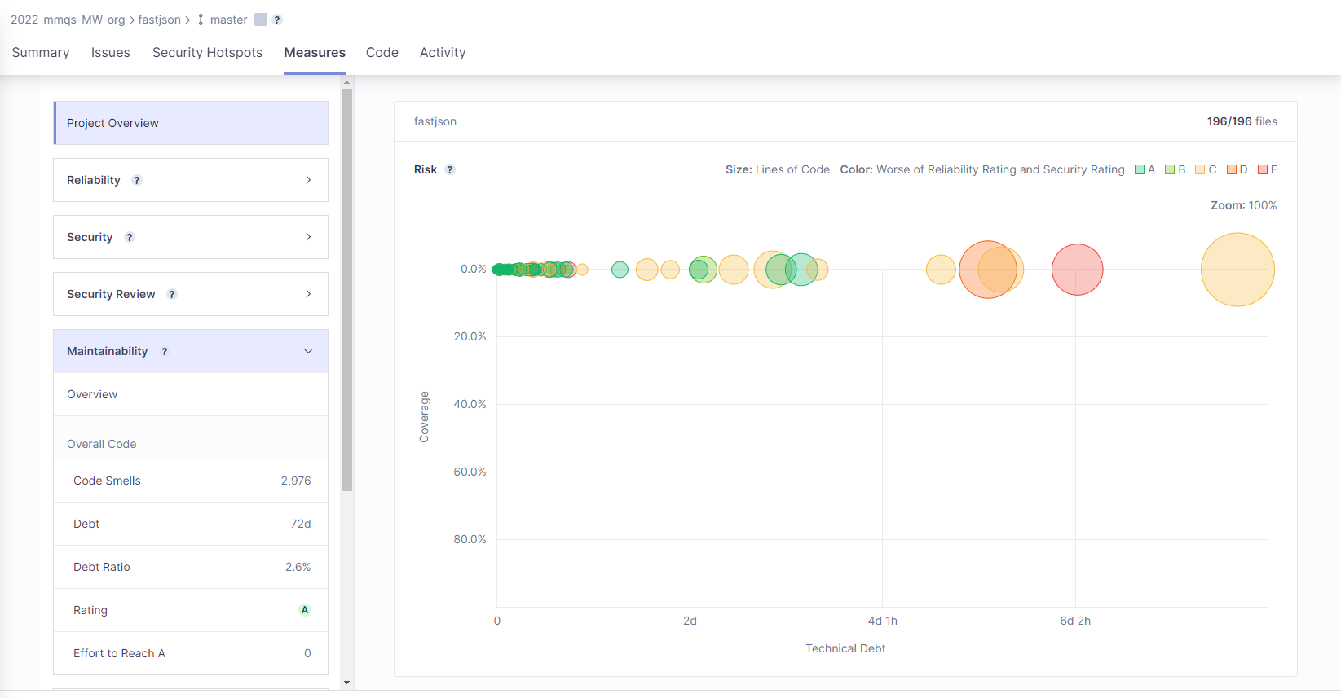

SCREEN FORTIFY

